# Storm Definition

## (Nathan and McMahon, 1990)

This base flow separation procedure is based upon a recursive digital filter commonly used in signal analysis and processing (Lyne and Hollick, 1979). The filter is of the simple form

$$f_{k}=αf_{k-1}+\frac{\left(1+α\right)}{2}+\left(y_{k}-y_{k-1}\right)$$

where fk is the filtered quick response at the kth sampling instant, yk is the original streamflow, and α is the filter (=0.9-0.95; best 0.925); the filtered base flow is thus defined as yk -fk.

Digital filter technique. Just as arbitrary as the other methods but is objective and repeatable. Filter parameter alpha=0.9-0.95. Default is 0.925. Three passes, forward, backward, forward again.

Compared to the smoothed minima technique the digital filter method is better suited to low base flow conditions, is less variable, and is more strongly correlated with other low-flow indicators. And more similar to results from manual approach.

## (Duvert et al., 2012)

It should be noted that due to the number of sites studied here, data processing and validation was not carried out by a single operator. Discharge and sediment data used for this study were initially processed by each of the local operators. Therefore, some criteria could slightly differ from one site to an- other, such as for instance the way of separating two successive flood events. This can partly explain the discrepancies observed in the number of events per year.

## (Duvert et al., 2010)

Doesn’t describe event definition.

## (Fahey et al., 2003)

Doesn’t describe event definition. Just says events with a minimum peak flow were included.

## (Rankl, 2004)

Doesn’t describe event definition.

## (Lewis et al., 2001)

Storm Definition and Feature Identification A total of 59 storm events occurred during the 11-year study. Storm events were generally included in the study when the peak discharge at SFC exceeded

0.0016 m3s-1ha-1 (recurrence interval about 7 times per year). A few smaller peaks were included in dry years.

Multiple peak hydrographs were treated as multiple storms when more than 24 hours separated the peaks and the discharge dropped by at least 50% in the intervening period. When multiple peak hydrographs were treated as a single storm, the discharge for the peaks analysis was identified by selecting the feature corresponding to the highest peak at NFC. Thus the same feature was used at all stations, even if it were not the highest peak of the hydrograph at all stations. However, differences in peak discharge caused by this procedure were very small.

The start of a storm was chosen by seeking a point on the hydrograph, identifiable at all stations, where the discharge began to rise. The start times differed by no more than a few hours at the various stations.

At the end of a storm, distinctive hydrograph features are more difficult to identify, unless a new start of rise is encountered. We therefore decided to use the same ending time for a given storm at all stations. The ending time was selected by observing the storm hydrograph for all stations and determining either the time of the next storm, the next significant rainfall, or a stable low-flow recession at all hydrographs, usually within about 3 days after the peak. The end of each storm was always well below the quickflow hydrograph separation point described by Hewlett and Hibbert [1967], except when the recession was interrupted by a new storm.

## (Gellis, 2013)

Rules were established to define a runoff event and peakflow in an event. In each of the four study basins, a runoff event was defined by a minimum peakflow. Hourly discharges for the period of study for each station were ranked to obtain the 95th percentile of discharge. The flow selected from the 95th percentile analysis was as the minimum peakflow that defined an event. The minimum peak discharges used to define an event for each of the study basins are shown in Table 3.

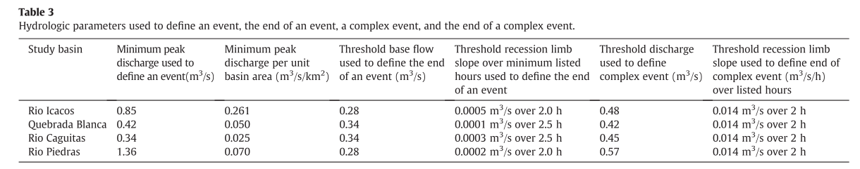

The start of runoff events was easy to discern for most events in the four basins as an abrupt rise in discharge. It was more difficult to determine when the runoff events ended. For consistency, a methodology was developed to define the end of the runoff event (Fig. 4a). The end of the runoff event was based on graphical features of the recessional portion of the hydrograph where a break in the maximum curvature of the recession curve or inflection point was selected as the point where surface flow ceases and base flow begins. The inflection point on the hydrograph recession curve was obtained by taking the second derivative of a 3rd-order best-fit regression line to the recession portion of the hydrograph (Fig. 4a). The second derivative of a 3rd-order equation is the inflection point of the curve or where concavity changes (Hughes-Hallett, 1994). In order for the inflection point to be considered the end of the event, the recessional limb of the storm hydrograph had to fall below a threshold base flow and reach a threshold slope (Table 3). The threshold base flow and slope of the recessional limb of the storm hydrograph were based on analysis of base-flow recession curves.

Events that are closely spaced in time are designated as “complex events” (Fig. 4b). In complex events, the recessional portions of the storm hydrographs approach but never reach base flow as defined for regular events. However, the individual runoff portions that make up the complex event may be considered isolated because discrete rainfall events are responsible for each rise in runoff. If a portion of a complex event was not sampled, it was ignored.

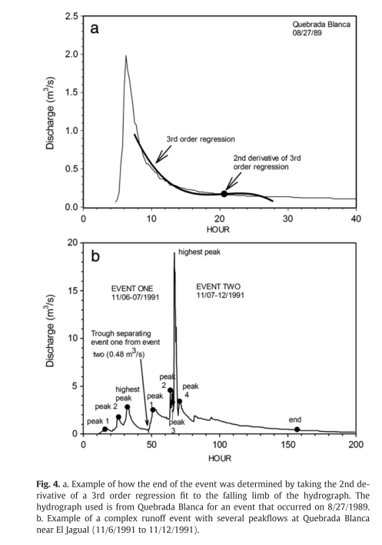

Complex event hydrographs were delineated into separate runoff events based on the following criteria. A threshold discharge and a threshold slope were developed for the recessional portion of the hydrograph for each basin (Table 3). The threshold discharge was based on examination of recession curves and was always higher than the value used to determine the end of a single event (Table 3). If the hydrograph recession met the threshold discharge and threshold slope criteria, the end of that portion of the complex event was selected just before the next hydrograph rise. The final recession limb of the complex event had to meet the criteria established for a single event.

The number of peaks in an event and their magnitudes are variables that can influence suspended-sediment characteristics (Walling, 1974). Some runoff events only have one peak, and the peak-flow characteristics are only defined for that peak. Other events are multi-peaked, defined by troughs and peaks. For multi-peaked events, a peak is defined by a minimum difference in discharge from the immediately preceding trough to the peak (Table 4). The minimum difference in discharge used to define each peak varied over a range of discharges. At each streamflow-gaging station, an analysis was made of peakflow minus the preceding trough flow. The peakflows were categorized into classes of 0–2.83 m3/s, 2.83–14.2 m3/s, and >14.2 m3/s. The minimum value obtained by subtracting the preceding trough flow from the peakflow in each class was used to define a minimum peakflow in a multi-peaked event (Table 4).Although some of the rules used to define hydrologic characteristics in Tables 3 and 4, such as the designation of the peakflow classes, may be considered qualitative, they nevertheless provided standardization in the statistical analysis among different watersheds.

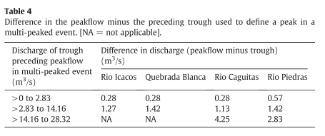

# References

Duvert, C., Gratiot, N., Evrard, O., Navratil, O., Némery, J., Prat, C., Esteves, M., 2010. Drivers of erosion and suspended sediment transport in three headwater catchments of the Mexican Central Highlands. Geomorphology 123, 243–256. doi:10.1016/j.geomorph.2010.07.016

Duvert, C., Nord, G., Gratiot, N., Navratil, O., Nadal-Romero, E., Mathys, N., Némery, J., Regüés, D., García-Ruiz, J.M., Gallart, F., Esteves, M., 2012. Towards prediction of suspended sediment yield from peak discharge in small erodible mountainous catchments (0.45–22km2) of France, Mexico and Spain. J. Hydrol. 454-455, 42–55. doi:10.1016/j.jhydrol.2012.05.048

Fahey, B.D., Marden, M., Phillips, C.J., 2003. Sediment yields from plantation forestry and pastoral farming, coastal Hawke’s Bay, North Island, New Zealand. J. Hydrol. 42, 27–38.

Gellis, A.C., 2013. Factors influencing storm-generated suspended-sediment concentrations and loads in four basins of contrasting land use, humid-tropical Puerto Rico. Catena 104, 39–57. doi:10.1016/j.catena.2012.10.018

Lewis, J., Mori, S.R., Keppeler, E.T., Ziemer, R.R., 2001. Impacts of Logging on Storm Peak Flows , Flow Volumes and Suspended Sediment Loads in Caspar Creek, CA, in: Land Use and Watersheds: Human Influence on Hydrology and Geomorphology in Urban and Forest Areas. pp. 1–76.

Lyne, V., Hollick, M., 1979. Stochastic time-variable rainfall-runoff modeling. Inst. Eng. Aust. Natl. Conf. 79.

Nathan, R.J., McMahon, T. a, 1990. Evaluation of Automated Techniques for Base Flow and Recession Analyses. Water Resour. Res. 26, 1465–1473. doi:10.1029/WR026i007p01465

Rankl, J.G., 2004. Relations Between Total-Sediment Load and Peak Discharge for Rainstorm Runoff on Five Ephemeral Streams in Wyoming. U.S. Geological Survey Water-Resources Investigations Report 02-4150. Denver, CO.